WHAT CAN GO INTO MY CURBSIDE CONTAINER?

ALUMINUM & TINS CANS:
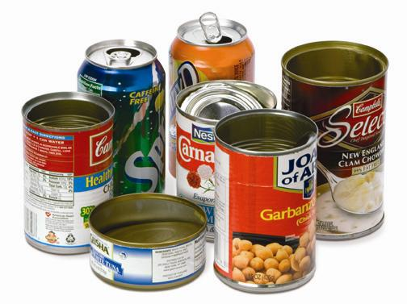

Food and Beverage containers are all accepted in your curbside container. Please be sure that they are empty and rinsed free of any contaminants before placing them into your cart.

CARDBOARD:

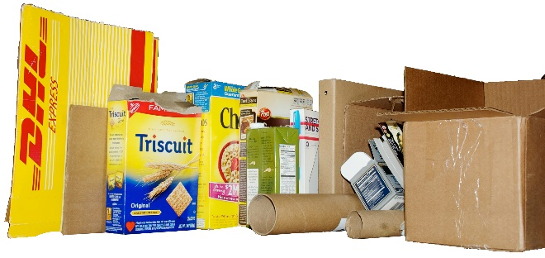Cardboard boxes are accepted in your curbside container. Please break it down and place it into your container. If you have excess cardboard, please stack it neatly in a pile next to your container. Pizza boxes must be free of grease and food before placing it into the container.

CARTONS:
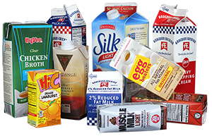

Milk, Juice and Food cartons are accepted in your curbside container. Please rinse them before placing them into the cart.

GLASS BOTTLES & JARS:
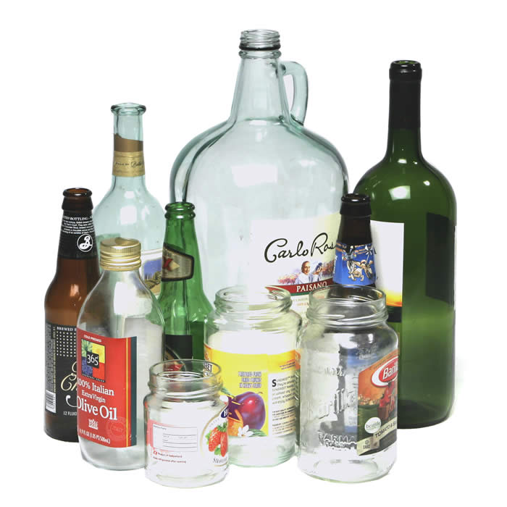

Glass Bottles and Jars are accepted in your curbside container. Please rinse them before placing them into the cart.

PAPER:
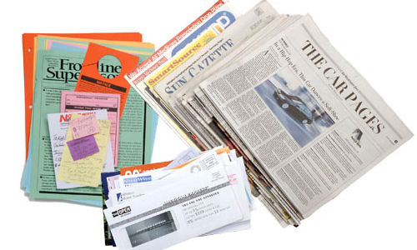

All Paper, Newspaper, Junk Mail, Magazines and Receipts are accepted in your curbside container. For shredded paper, please place it in a paper bag and label it shredding.

PLASTICS:
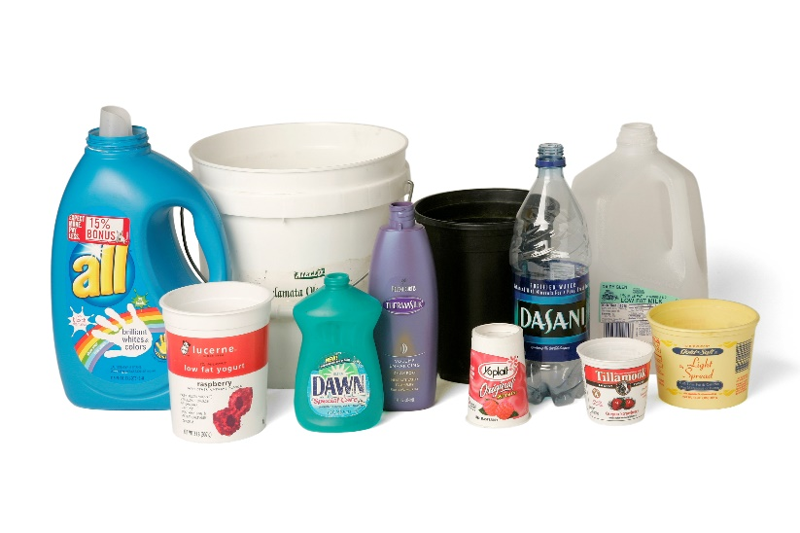

Plastics labeled #1, #2, #3, #4, #5 and #7 are all accepted in your curbside container. Please rinse them and place the lids back on the containers before placing them into your cart.

